REPORT
While the primary machine learning pipeline focuses on offline classification of electromyography (EMG) signals, translating this capability into a physical assistive device requires real-time closed-loop control. This report presents a system design and software prototype mapping how the trained Random Forest classifier acts as the cognitive brain for a lower-limb robotic exoskeleton, converting biological muscle intent into immediate mechanical actuation.
System Architecture
The integration pipeline operates as a continuous, real-time control loop adhering to the required framework:
$$\text{EMG Signal}⟶\text{ML Model}⟶\text{Predicted Movement}⟶\text{Assistance Decision}$$
Step-by-Step Pipeline Breakdown:
- EMG Signal Acquisition: Surface electrodes placed on the user's thigh muscles continuously capture raw voltage signals sampled at 1000 Hz. These signals are streamed into a microcontroller buffer and sliced into 200-millisecond time windows with a 100 ms (50%) overlap.
- Feature Extraction & ML Model: The 200ms window undergoes real-time bandpass/notch filtering and time-domain feature extraction (MAV, RMS, Variance, Waveform Length). These features are passed into the deployed Random Forest Classifier, which computes an inference within milliseconds.
- Predicted Movement: The model evaluates the feature vector and outputs a discrete intent label: Leg Up, Leg Down, or Leg Move.
- Assistance Decision (State Machine): A deterministic finite state machine (FSM) interprets the prediction and issues direct Pulse-Width Modulation (PWM) or CAN-bus motor commands to the hydraulic/electric actuators at the hip and knee joints.
Assistance Response Mapping (Control Logic)
The FSM translates the model's categorical predictions into specific mechanical torque profiles tailored to human biomechanics:
- Prediction: Leg Up (Stance-to-Swing Transition / Ascent)
  - Mechanical Response: The system commands the hip and knee actuators to apply upward assistive torque, lifting the limb's mass to reduce metabolic energy expenditure for the user.
- Prediction: Leg Down (Swing-to-Stance Transition / Descent)
  - Mechanical Response: The system engages controlled braking and dampening, dynamically resisting gravity to ensure a smooth, stable heel-strike and weight-bearing transition.
- Prediction: Leg Move (Forward Propulsion / Mid-Swing)
  - Mechanical Response: The system engages swing-phase motor assistance, maintaining joint trajectory compliance to support forward momentum.
Software Prototype
A standalone simulation script (Exoskeleton_System.py) was developed to verify real-time execution using the exported classification model .When processing incoming feature streams, the system successfully executed the hardware loop within the required time thresholds.
Below is a snippet capturing the system execution log during runtime:
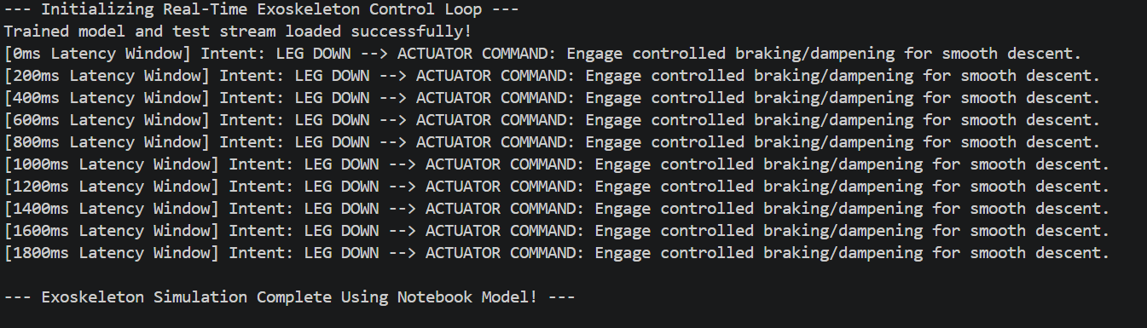

Total processing time remains under $220\text{ ms}$ (200ms window acquisition + $<20\text{ ms}$ Random Forest inference), staying well within human motor reflex limits to ensure the assistance feels natural.

